SAP Application Development

(S/4 HANA)

HTML5, CSS & JavaScript

Motivation
This chapter explains how an initial web application using solely HTML5, CSS and JavaScript will be developed. Therefore, you will learn how a basic web application is structured, how its layout can be designed and how the application logic can be implemented.

Content
This chapter explains how an initial web application simulating a Rock-Paper-Scissors game can be implemented. For this, first a new web application project will be created in Eclipse. Afterwards, a static HTML5 page will be implemented, followed by the creation of a CSS stylesheet which will define the layout of the HTML5 page. Finally, JavaScript functions will be implemented, which determines the logic of the web application.
Prerequisites
Before starting the exercises, you should have fundamental programming skills and be familiar with the basic navigation in the Eclipse IDE.

Lecture notes
This chapter is independent from any SAP system. Therefore, students do not need system access for this exercise. However, it is recommended that they have a current web browser installed. Furthermore, this chapter deviates from the flight example which is used in most of the other exercises, but focusses on the development of a small web-based game.

- Product: All

- Level: Beginner

- Focus: Programming

- Version: 2.0

- Author: UCC Technical University of Munich

Task 1: Create Web Application Project
Short description: Creating a new web project, which contains HTML5, CSS and JavaScript files
Create new Project

In the context menu of the Project Explorer, choose New->Other->General->Project.

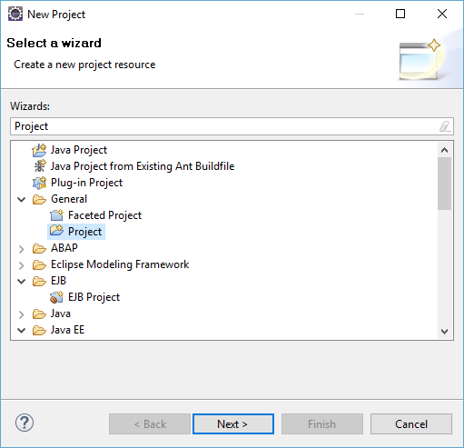

On the next screen, name your project Rock-Paper-Scissors (no need to add your 2-digit number ##, since you are developing locally in this exercise), and let all other fields as they are. Click on Finish.

Your initially empty project will now appear in the Project Explorer. Since we want to develop a working web application with HTML5, CSS and JavaScript in this exercise, a suitable project structure is needed to keep an overall view of the source files. Therefore, four folders shall be created for the different source files. In the context menu of your project, choose New->Folder, and enter Folder Name views, which shall contain your HTML5 files later. Click Finish.

Create Folders
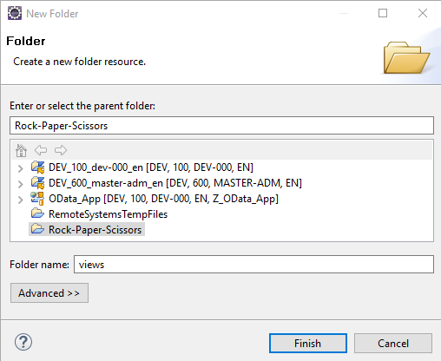
Repeat this step three times, and create the folders style, which will contain your CSS files, logic, which will contain your JavaScript files, and library, which will contain your libraries later.

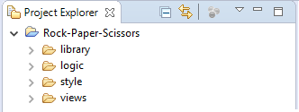

Finally, since we want to develop a web application, make sure that the Web perspective is opened in Eclipse. You can check this on the top right of the UI.



If the Web perspective is not yet available there, choose Window->Perspective->Open Perspective->Other, and add it to your perspective selection.

Open Web Perspective
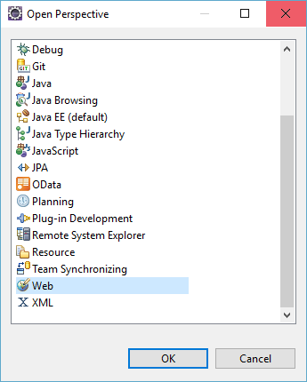

Task 2: Create a static HTML5 page
Short description: Creating a static HTML5 page which represents a User Interface to play Rock-Paper-Scissors

In the context menu of your views folder, select New->Other->Web->HTML file, enter File name play.html, and click on Next. There, select to use an HTML template, and make sure that New HTML File (5) is selected. Afterwards, click Finish.
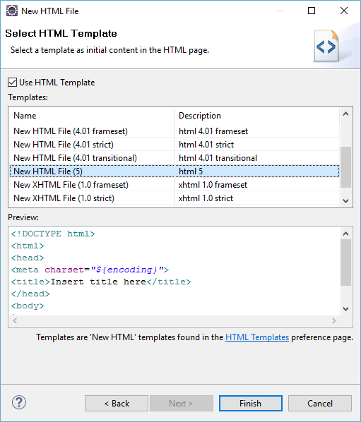
Create HTML5 file

An initial template for your HTML file will be created.

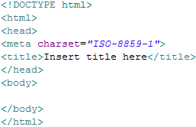

In the next step, we want to create the static elements which will be shown to the user in the browser later. First, enter Rock-Paper-Scissors as title between the <title>-tags. Afterwards, add a headline <h1> in the body section with the text Welcome to Rock-Paper-Scissors, and a sub-headline <h3> with the description text Make your choice and beat the computer in multiple rounds!

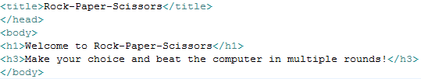

Next, a fieldset shall be created with which you can select the game mode and make your selection whether you choose rock, paper, or scissors. For this purpose, you have to create different fields, and a list which shows the fields in a structured way. Furthermore, the details of the different input fields have to be determined. For example, for the game mode, we want to create a dropdown menu. For the Rock-Paper-Scissors selection, we want to use three radio buttons, from which only one can be selected. Altogether, an input button shall start the game with the chosen selection. To implement all these functionalities, add the following program code to the body section of the play.html page:

Add content to HTML5 file
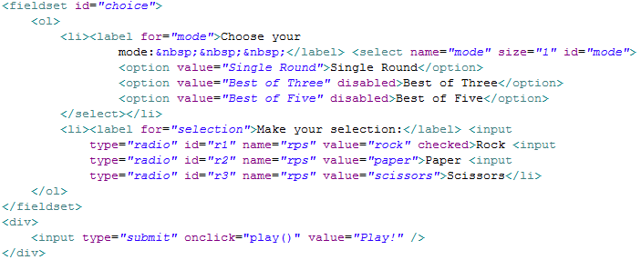

Thereby, the basic elements of the HTML page were implemented. To test the page in this initial status, save it, right-click on your play.html page, and choose Open With->Web Browser. A new tab will open in Eclipse, which shows you the current state of your HTML page. It should look like this:

Display initial web page
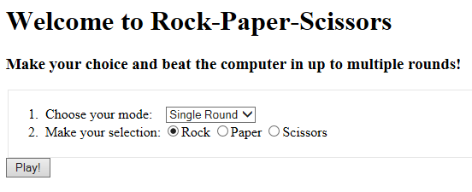

As you can see, the page currently shows only structured text, but does not contain any style elements. These will follow in the next task, when CSS stylesheets will be included.

To show the results of the Rock-Paper-Scissors game, a dynamic table shall be added to the HTML page, which will be filled with statements whether you won or lost the game. For this purpose, a static table template has to be created, which will only be shown when game results are available. Therefore, please add the following HTML5 code to the body part of the play.html file (do not forget to save your file afterwards):

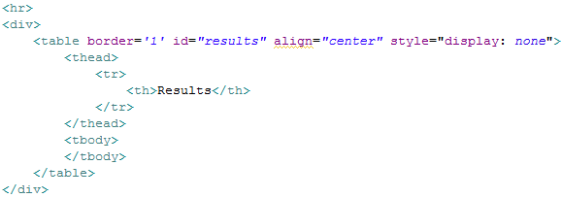

Task 3: Create CSS Stylesheets
Short description: Creating a stylesheet which defines style and layout elements for both HTML pages

In order to define style elements for your HTML page, a central stylesheet file has to be created, which will be included in your HTML file. Therefore, since the style definitions in your CSS file shall be valid for your play.html page, first add the following line to its header area, which will include the style definitions:

Afterwards, we have to create the CSS stylesheet. For this purpose, in the context menu of the style folder, select New->Other->Web->CSS file. Enter the name style.css and click on Finish.

Create CSS stylesheet
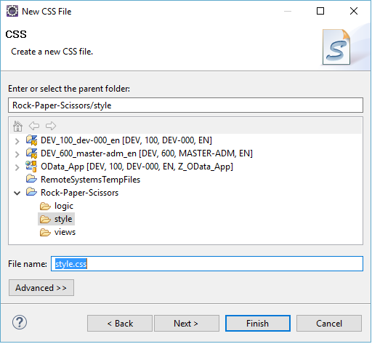

First, we want to define the background color of the web page, and the style of the shown headlines. For this purpose, add the following code to the CSS file:

Add style definitions for texts and body
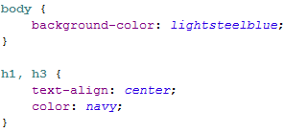

The background-color, respectively color attribute simply define the color in which the HTML element shall be displayed. The text-align attribute defines how content shall be aligned. In this case, the headlines h1 and h3 shall be aligned to the center of the page.

Next, the style of the input fields will be defined. For this, add the following code to the CSS file:

Add style definitions for input fields
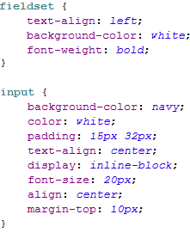

Again, the text alignment and the color of the elements are defined. Furthermore, the font-weight and font-size define how text within HTML elements is displayed. Moreover, the padding and margin-top attributes determine the size and distance of elements.

Finally, the style of the table, which will show the results of the Rock-Paper-Scissors games, is defined. Please add the following code to the CSS file:

Add style definitions for table
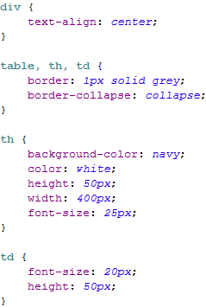

Save your CSS stylesheet. Again, font sizes, colors and text alignments are determined. Furthermore, for the table, the border style and color is defined, as well as the height and width for the table headers.

Remark: Manually defining styles in CSS files is a difficult and time-consuming task. In modern web development, this is no longer done manually. For most cases, extensive libraries exist which simplify the style definitions of web pages. This is also the case for developing SAPUI5 applications. However, in this exercise, we shortly demonstrated how manual CSS code is developed, since it is still important to understand how HTML5 and CSS are related.

Task 4: Create application logic with JavaScript
Short description: Creating a JavaScript file which contains the application logic of the HTML5 page by defining respective functions

To implement the application logic of your web application, first a JavaScript file has to be created which will contain the program code. Therefore, right-click on the logic folder of your project, and select New->Other->JavaScript->JavaScript Source File. Click on Next, enter the name logical-flow, and click on Finish.

Create JavaScript file
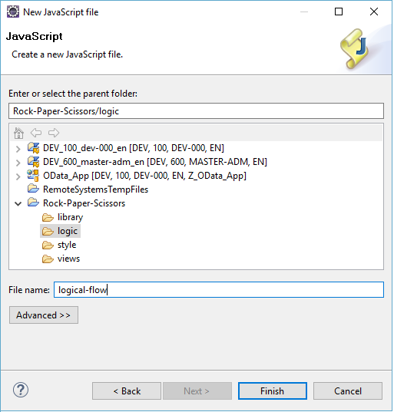

Since we want to use jQuery to simplify the manipulation of HTML5 objects, please go to http://jquery.com/download/, and download the current version of the compressed jQuery source file. Rename the downloaded file to jquery.js, and add it to the library folder of your project.

Next, we want to include the downloaded jQuery library, as well as the created logical-flow.js file. Therefore, please go to your play.html page, and add the following lines to the header section (do not forget to save afterwards):

Now, we are prepared to implement the application logic using JavaScript and jQuery. As you may have probably noticed, in the play.html file, we used the onclick()-event of the input button to call the function play(). However, we did not implement this function so far. Therefore, we want to add it to our JavaScript file. The function shall read the mode the user selected for his game, and call additional functions to play the game and show the results. Hence, add the following code to your logical-flow.js file:

Add JavaScript functionalities
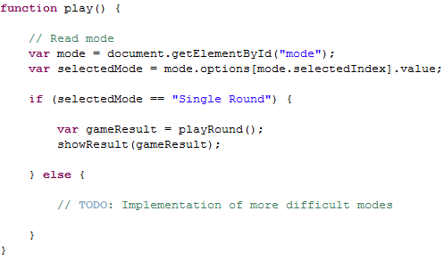

As implemented, the program code reads the mode and calls the playRound() function to play the game. Depending on whether you won or lost the game, the showResult()-function shows a respective message. Currently, we only implemented the mode to play a single round, for which reason, the other two modes are not working. Implementing one of these modes will be part of the challenge which follows at the end of this exercise.

The playRound() function contains the central logic of the web application with regard to computing which player won the game. This function first reads the selection of Player 1, which is the one using the web application. Afterwards, it computes a random number between 1 and 3, which determines whether Player 2 (the computer) chooses rock, paper, or scissors. Finally, the selections of Player 1 and 2 are compared and the winner is determined. To implement these functionalities, please add the following JavaScript code to your file:

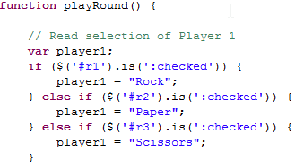

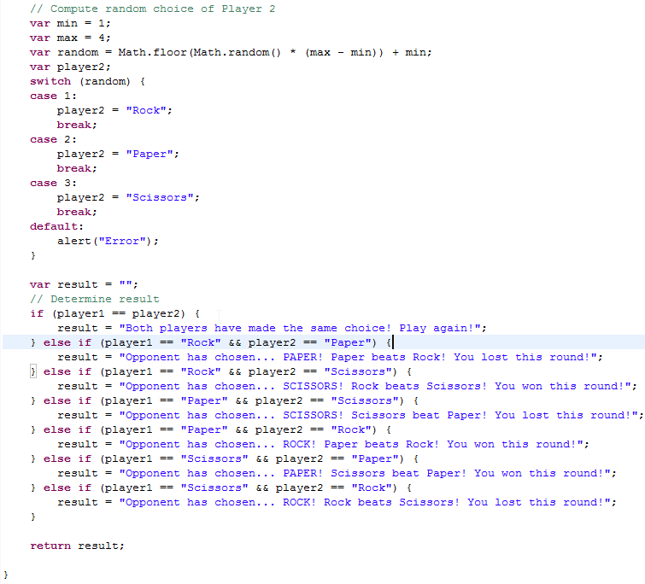

Manipulate DOM
Finally, the result determined by the playRound()-function shall be shown to the user. For this purpose, the table template defined in the play.html file has to be extended and displayed to the user. Therefore, please add the following function to your JavaScript file:

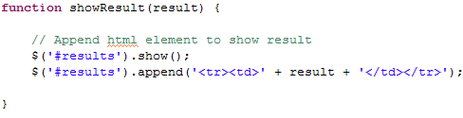

Save your JavaScript file. Finally, your web application has been implemented. If you already want to test it, right-click on your play.html file, and choose Open With->Web Browser. If you implemented all steps correctly, the web page will be shown with your style definitions, and by clicking on play, the results of the game will be shown in a table. You can also copy the link of your local play.html file, which is shown at the top of the integrated browser, into a local web browser (e.g. Chrome). This way, you can inspect the source code with the integrated developer tools of your browser.

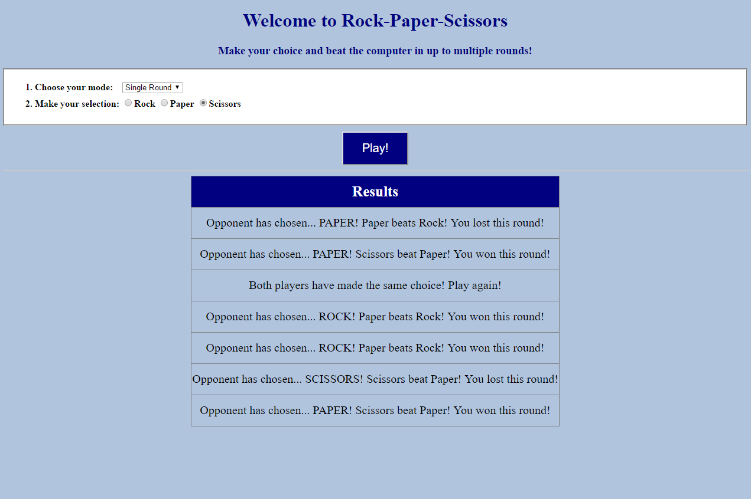

Challenge: Implement the additional mode “Best of Three”
Task 1: Currently, if a user selects another mode except Single Round, nothing happens. Please extend the game by implementing the Best of Three mode. Extend the play method by reacting to the event if a user chooses the Best of Three mode. In this case, call the playRound function as it is done for the Single Round mode. However, after every round, further add the following text to the table: “Note: You have chosen Best of Three mode. Please evaluate whether one of the players already won the game!”

Task 2 (difficult!): Collect information about cookies in JavaScript, e.g. on http://www.w3schools.com/js/js_cookies.asp. Implement a counter with cookies, which counts the number of rounds played in the current Best of Three game. To simplify the rules, assume that every Best of Three game has three rounds, even if one player has already won after round 2. In the play function, read the current round number from the cookie. If you have already reached round 3 (and only in this case), add the following text to the table: “Three rounds were played in the Best of Three mode. The game is over. Please evaluate who won the game!”

